Requirements Document

CS 300 - Group Project (Team 1)

Bader Alshaya

Boodhi Alshaikh

Dhwanil Chokshi

Zack Salah

**Table of Contents**

**1 Introduction**

1.1 Purpose and Scope

1.2 Target Audience

1.3 Terms and Definitions

**2 Product Overview**

2.1 Users and Stakeholders

2.1.1 Member (User)

2.1.2 Provider (Stakeholder)

2.2 Use Cases

2.2.1 Manage Member Account

2.2.2 Provide Health Care Service

2.2.3 Manage Monthly/Weekly Payments

**3 Functional Requirements**

3.1 User Interaction

3.2 Functional Process

3.3 Maintainability and Updatability

3.4 Reliability, Safety and Security

3.4.1 Efficiency timing

**4 Nonfunctional Requirements**

4.1 Security

4.1.1 Data Storage

4.1.2 Accessibility

4.2 Software Usability

4.3 Verification Constraints

4.3.1 Time Constraints

**5 Milestones and Deliverables**

5.1 Product Documentations

5.1.1 Requirement Documentation

5.1.2 Design Documentation

5.1.3 Test Plan Documentation

5.2 Software Documentation

# 

# 

# **1 Introduction**

This document is the requirements document which highlights some of the most important features in the Chocoholics Anonymous software processing project. This document is important because it establishes a bridge between what a customer wants and what a developer can do. Most important features of the requirement specification involve an in-depth analysis of the functional and nonfunctional requirements, with discussion of the many stakeholders playing an important role in the construction and usage of the software. Furthermore, the requirements document plays a major role in the initial steps , facilitating an easy path to development of project design without the unnecessary anxiety and stress of having to redesign important features later on. Since the requirement document will be a key piece in connecting the customer and developer with the product, it is vital that the developers (at ChocAn) have a thorough understanding of all the requirements for a fully functional development of software.

Chocoholics Anonymous is an organization that helps individuals who are addicted to chocolate and can’t seem to get past their addiction. The organization consists mainly of many health care professionals who specialize in different areas to help the individuals overcome their addiction and live a healthy lifestyle. There are many different types of health care professionals, ranging from dieticians to exercise specialists.

The project at hand involves creation of a software which the health care professionals (providers) can use to successfully provide the ChocAn members the services they need. The members, who are attending ChocAn for services, should be able to easily access professionals and use the services as long as they are paying their monthly membership fees. A huge part in the development of this software includes having a provider terminal which will be able to validate or invalidate the members of ChocAn. This is mainly done through using the member and provider numbers. After the use of ChocAn service, the provider will once again slide the member card, or enter the member number to see if the member is valid. Once the validation has been confirmed, the provider will enter the information about the date on which the service was provided, and the provider uses the provider directory to see the service code for the service which was provided. When the service code has been searched, the provider is asked to verify that the service code is in fact the correct one.

The software now writes a record which consists of the current date/time, the date the service was provided, provider number, member number, service code, and comments. The software looks up the fee to be paid for the service and asks the provider to fill in a form regarding the information of services provided to bill ChocAn at the end of the week. The provider directory should be accessible by the provider at any time, consisting of alphabetically listed names of services.

At the end of the week, the members of ChocAn receive an email attachment which lists the services provided to that member sorted by the service date. Similarly, at the end of the week, the providers also receive an email attachment with information regarding the number of total consultations they provided to the members and total fees sorted by service date. The Electronic Funds Transfer ensures, that the total amount of money that the provider should have is credited to the provider’s account.

The ChocAn data center runs throughout the day, giving the users ability to add, delete, or edit member and provider information. Acme Accounting Services is responsible for handling the member’s membership fee, suspending and reinstating them based on their payments.

## **1.1 Purpose and Scope**

The general and broad purpose of this requirements document is to provide proper means of documentation for some of the most important stakeholders that play a direct part in the use of software. For Chocoholics Anonymous, this would be the company itself, and the health care professionals that work in the specialized sectors of treatment. Overall, Chocoholics Anonymous will use this software for the generalized purpose of offering a service to the members, through its providers. However, the providers are equally important stakeholders who will use the software to log details about services and earn money. Therefore, the requirements covered in this document serve an important function in providing the proper documentation to it’s users. However, from a more technical standpoint, the purpose of this document is to sort and analyze all the necessary requirements for the software, which will satisfy the developers, customers, and all other important stakeholders. A document such as this is responsible for delivering the functional and nonfunctional requirements for the developers. It will clearly and precisely identify all the necessary requirements of how the features of the software should function to make a final collaborative product. Requirements not only emphasize the internal functioning, but also the external specs of the software from user’s perspective. We, as contracting developers for Chocoholics Anonymous, have to make sure that the user interface is friendly to it’s users, avoiding lengthy error messages which may not be understood by the user.

A document such as this can also help in the better understanding of what exactly the product is and how it will function. Better understanding of the product is essential to a creation which will satisfy the customers. Requirements document can be used to jot ideas which are considered important and minimize room for error pertaining to any grey areas.

The scope of this document involves starting with the introduction, which describes the project we will be developing for Chocoholics Anonymous. The focus then shifts into the product overview which will describe the important stakeholders that are part of this development project. Product overview will also describe the use cases, identifying the participants, humans, and other experimental participators who will be in direct contact with the software. The main bulk of this document consists of important information regarding the functional and nonfunctional requirements which will be assigned in their respective categories. The functional requirements will cover the technical details and important components in the making the system function smoothly and effectively. Similarly nonfunctional requirements will cover the criteria which can be used to make the system function in a more efficient, secure, and best possible manner. Lastly, the document will cover the deliverables and milestones which are essential to keeping the developers in check with the necessary components being finished as promised. It will include the workflow plan and other charts which will cover the internal and external successes the team has had with regards to the project.

## **1.2 Target Audience**

The target audience for this document can be broken down into categories representing the primary target audience and secondary target audience. Primary target audience represents those which are the most direct target of this document, and secondary target audience represents those who are the indirect target audience.

* Primary Target Audience (Developers): The software developers who are given the contract to work for Chocoholics Anonymous are one of the most important target audience for this document. Writing the proper requirements serve as a connection which will allow the developers to create a product which will in the end be able to benefit the developers and the customer. Furthermore, requirements document like this one highlight the important specs and features which must be implemented into the final product. The absence of a document like this may result in production errors such as overproduction, underproduction, or erroneous production. Developers should be in touch with this document throughout all stages of production so they are aware of the direction they are headed in.
* Primary Target Audience (Customer - Chocoholics Anonymous): On the other end of the spectrum is the customer, for whom we are doing all the work (in our case - Chocoholics Anonymous). They are a very important stakeholder, and this makes them an equally salient target audience. Requirements Specification serves as an important link which ensures that Chocoholics Anonymous’ realistic expectations are fulfilled for the price they pay. Additionally, a document like this will take note of the important functional requirements which must be implemented no matter what.
* Secondary Target Audience (Members and Providers): A document such as this proves to a vital source of documentation for the health care professionals. It incorporates all the necessary functionality to assure that the health care professionals and members of Chocoholic services are able to easily use the software. We, as developers, want to make sure that the interface and user interaction flows pretty easily in a manner that is satisfying to both the providers and members.
* Secondary Target Audience (Contracting Managers): The managers who are responsible for oversight are also a target audience for this document. Requirements specifications serve as an ‘indicator’ document which the managers can use to check that all customer requests have been met by developers. Furthermore, the managers have to guarantee that certain milestones are reached in order to have a more satisfied customer. For example, if the customer is expecting a prototype, managers are responsible for making sure that the developers finish important components of the project to have a working prototype in front of the customer as promised.

## **1.3 Terms and Definitions**

The following table consists of the terms and their respective definitions that will be used in this document. It contains acronyms, customer-related terms, and software-related terms which will help in better understanding of the technicality to all readers of this document.

|  |  |
| --- | --- |
| **Terms** | **Definition** |
| ChocAn | Chocoholics Anonymous - the company for which were creating software |
| Providers | HealthCare Professionals who are specialized and provide a service to ChocAn members |
| Customer | Chocoholics Anonymous |
| Members | Users of ChocAn’s services by consulting with ChocAn providers |
| Service Code | 6 digit code for service providers provide to the members |
| ChocAn Data Center | Center responsible for handling member information |
| Provider Directory | Directory with information about services providers provide and the service code |
| EFT | Electronic Funds Transfer responsible for making sure providers get paid |
| Acme Accounting Services | Responsible for handling membership fees, suspending and reinstating members |
| Terminal | Interface used by providers and ChocAn to use the software |
| Text-file | File containing reports which will be sent to providers, members with information about services used |

# 

# **2 Product Overview**

In this section, we describe the type of product this software offers, who is it for, and who are the consumers of this product. Explicitly, we will specify the different stakeholders and the end-users for this product. We will also give a specific layout for the use cases and how it is handled within the software. Then, we will make a thorough explanation of the project functionality and how each stakeholder interacts with it. Finally, we will touch on the scope of this product and what are the features that are included or excluded from this product.

This product (software) controls the transaction process between the member (customer) and the ultimate provider (employee), which in this case is the Chocoholics Anonymous organization (ChocAn). Basically, to get the service defined by this product the customer applies for it by meeting a service provider of ChocAn. The service provider, then, asks the customer to provide their membership card. However, if they don’t have a valid membership card, the provider asks the user to setup a new member account with ChocAn and receive a new membership card.

After setting up the user account, the provider then asks the member about their desired health care services to be enrolled in. In this process, the provider print out the different healthcare services provided by ChocAn and their associated information. Then, the member gets to choose one or more of the offered services. After selecting all desired services, the provider goes ahead and fill out the transaction form with all the details regarding this transaction. Finally, just before the provider submits the transaction to the system, an overview of the transaction is printed out for the member. So, the provider asks the member at this step to read over the transaction summary and verify all of the details before completing this transaction.

When the user verifies the transaction details, the provider submits the transaction and store a record of it under the user account. At this stage, both members transactions and providers fees must be monitored by the system on a regular basis to keep track of fees and balances of both members and providers.

**2.1 Users and Stakeholders**

Here we will show the different stakeholders within this product and how they correlate with each other or/and with the end-user. However, in this section, we will leave the layout somewhat incomplete for the further sections to thoroughly explain the different roles of each stakeholder in great details. Nevertheless, we will give a brief description of each major task within ChocAn organization and who is involved in these tasks specifically and how.

2.1.1 Member (User)

The member represents the end-user of this product. The member specifically represents the person who is labeled as an addict to chocolates in general and looking for some serious help from expert health care representative. The member is entitled to unlimited consultations with healthcare professionals and other health services. In return the pay a monthly fee to get their membership with ChocAn. Health care services are listed below.

|  |  |
| --- | --- |
| **Services Type** | **Scope** |
| Dietitians | Manage the patient’s diet |
| Internists | Manage the patient’s internal medicine |
| Exercise Specialist | Manage the patient’s exercise routine and practice |

2.1.2 Provider (Stakeholder)

Providers are branched as one of the stakeholders in this product. They act as hired mediators that mediate over non-technical users and technical interface known as the provider’s terminal. In return, the providers get paid at the end of each week by the number of consultation and the number of services being provided to members by that provider.

**2.2 Use Cases**

Use cases are the part in which this paper gives an abstract description and layout of the major interactions between the end-user and the service provider. These interactions are known as use cases. We divided this interaction, based on the writing description of the ChocAn product, into three section as follow.

2.2.1 Manage Member Account

One of the main interactions between the client-provider at ChocAn and the end-user lies under the process of member’s (end-user) account managing. Mainly, this interaction would take place when a new member visits a ChocAn provider to set up a new member account or to maintain their precious accounts to be eligible for other ChocAn services. Such as getting unlimited access to ChocAn services, seeking health care assistance, and receive mentoring sessions in regard to healthy diets and exercises.

2.2.2 Provide Health Care Service

Another major interaction between members and providers are the process of providing health care services to existing members or newly registered members. This process requires various tools and conditions to accomplish such a task. Required tools can be listed as the provider's terminal, the data center, and eventually the written software. However, this use case can be conditioned into two scenarios. The first one is when a returned member come to renew their membership or solve a suspension due to some violation. On the other hand, when a new member sees a ChocAn provider and asks for a new membership, the provider would need to create a new membership account for that member and add services as needed.

2.2.3 Manage Monthly/Weekly Payments

For all of the previous major tasks, a payment is due at different periods of time based on the type of task that took place. So, if a member got a health care service with ChocAn, then the member must pay a monthly payment in return. Moreover, providers are hired, hence, they must get paid. Providers payments are arranged weekly based on the number of services being provided and the number of given consultations. However, these payments also need to be processed by the provider through the terminal and specific reports get copied to the data center and eventually gets sent to the manager of ChocAn.

# **3 Functional Requirements**

The purpose of this section is to explain how the application is going to be functioning and organizing data. That includes adding members, retrieving members from a text file based on their name, storing providers information and the service date, removing members who have resigned from the program, update members records and also the ability to retrieve that information. Also, the application will record all services that members get by storing the information into a text file. Another feature is that the application will look up the fees to be paid for each service and show it on the provider’s terminal which will promote to the provider a form to enter the current date, the date that service was provided and the member information. All information that will be stored, will be sorted out by date so that displaying data will be more convenient. Many data structures will be used that will help to store and modifying data. There are many things will be discussed in this section that will explain the flow of how this application would work.

First of all, once the provider slides the member's card, it will check if the user is suspended or not and display a message if the user was suspended. However, the suspension of the user will not be one of the functionalities because another contributing company will be working on that part. On the other hand, if the user’s status was valid, the input will be taken from the provider to store the date of the member’s billing. Then, the provider can use the Provider Directory feature to look up service code for any service. If it the code was found the application will display the service corresponding with that code and it would verify if it was the correct service to be edited. However, if the code was not found, an error message will get popped up indicating the code was not found, but if not, it will give the provider the choice to add comments for the service that was provided. For example, the date and time to keep the record of the time that service was provided, the provider’s number to know who’s the employee who edited the directory. Also, the member’s number to know who’s the member that service was meant for. Finally, the service code to know what is the service that’s being served for the member and the option of adding some comments for the record. The application should display the total for that recorded service in the provider’s terminal.

Members who were consulted by ChocAn providers will get a report of the services that were provided to them, sorted in order of the date that service was provided and it will be sent via email. That record will have several different information about that task. It will have the member’s full name with a maximum of 25 characters, the member’s number with a maximum of 9 digits, the member’s address of residence with maximum of 25 characters, the city where the member lives with a maximum of 14 characters, the state where the member is located with maximum of 2 letters and the zip code of that location with maximum of 5 digits. Also, with every service, it will have the provider’s name with a maximum of 25 characters, the service name with a maximum of 20 characters and the date of that service as (MM- DD - YYYY).

Providers who provided services to ChocAn clients shall receive a report via email that will have information about the services and summery of that tasks that were provided by the provider. It will have the provider's full name, number, address, city, state and zip code. Also, it will have information about the services like date of the service, date and time that data was saved, the name of the member who's that service was provided for, the member’s number, the service code and the fee to be paid up to $999,99.

## **3.1 User Interaction**

The application will be basic application and it will prompt the user for actions and takes the user input. Based on the user input, it will get to the next course of action and prompt the user again. There will always be a choice to exit the program, so we give the user the choice whenever the user feels to end it. There will error messages if the input taken wasn't possible to work so that the user will have aware of illegal actions in the application.

**3.2 Functional Process**

This section will include the functionality from the user end. The user (Provider) will have to interact with the terminal, in which our software is installed. The software will have a user-friendly interface. The language will be precise and easy to follow. Each menu will consist of list options that will help the user to record their patients (Member) effectually. Below is a list of user interactions with the software:

* The Software will receive a member card and it will give out their member status and fees owed.
* A provider must enter the date and the service provided. The date must be in following format - MM-DD-YYYY. The provider must also, use the provider's dictionary to retrieve the appropriate six-digit number, ex. (598470 -> dietitian), which corresponds to the services given to the member. They must enter the retrieved service number and enter it in the terminal. The software will display the service number and the corresponding name up 20 characters for the provider to verify.
* After the provider finishes the Member report, the software retrieves the service number and displays service name and the fee associated with it.

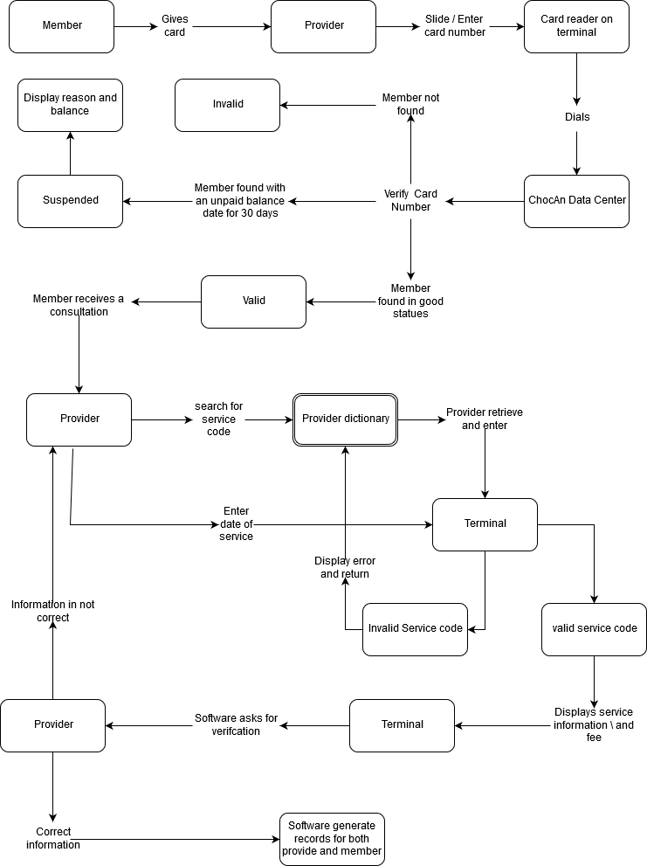

### **3.3 Maintainability and Updatability**

The user (Provider) interact with the software to record a ChocAn member visit via the terminal. The provider must use the service dictionary to retrieve a service code for the service the provider delivered. The service dictionary can be requested by a provider at any time. The software generates records for the member, provider, EFT, and summary reports. The report shall be generated weekly. The report will be formatted as files (.txt) and then sent to the individuals associated with the report. Reports shall be sent from the previously saved data from a (.txt) file and give the provider a choice to show or modify that data by adding services for members. The process should be fast and efficient and should not take much time. The provider's information will be retrieved from a different text file and all of the information retrieved will be saved into a hash table which will give O(1) retrieval if there was no collision. The Provider Directory will be an alphabetically ordered list of service names with it service code and it’s fees.

Below is a list of what the software generates and formatted:

* The software shall write a record to the disk that includes the following fields:

Table 1

|  |  |
| --- | --- |
| Records includes | Format |
| Current date and time (received by the computer) | MM-DD-YYYY |
| Date of service provided | MM-DD-YYYY |
| Provider number | 9 Digits |
| Member number | 9 Digits |
| Service code | 6 Digits |

* Members who receive a service from a provider will receive a report with the list of services provided to the member. The report will be in the following format:
  + Member informations:

Table 2

|  |  |
| --- | --- |
| Records includes | Format |
| Member name | 25 Characters |
| Member number | 9 Digits |
| Member street address | 25 Characters |
| Member city | 14 Characters |
| Member state | 2 Characters |
| Member zip code | 5 Digits |

* + - Set of List of services provided to the member:

Table 3

|  |  |
| --- | --- |
| Records includes | Format |
| Date of service | MM-DD-YYYY |
| Provider name | 25 Characters |
| Service name | 20 Characters |

* The software shall generate a report for providers who have billed ChocAn during the week. The report shall contain a list of services which was provided to ChocAn members. The report shall contain the following information:
  + Provider’s list of services and fees

Table 4

|  |  |
| --- | --- |
| Records includes | Format |
| Provider name | 25 Characters |
| Provider number | 9 Digits |
| Provider street address | 25 Characters |
| Provider city | 14 Characters |
| Provider states | 2 Characters |
| Provider zip code | 5 Digits |
| List of tables of services provided - Format is identical to table 1  +  Fee to be paid - $999.99 Limit | |
| Total number of consultation | 3 Digits |
| Total fee for the week | $99,999.99 Limit |

* The software shall generate an EFT report. The report will include the following information:

Table 5

|  |  |
| --- | --- |
| Record includes | Format |
| Provider name | 25 Characters |
| Provider number | 9 Digits |
| Amount to transfer | $99,999.99 Limit |

* The software will generate a summary report which will be directed to the manager account playable. This report will contain the following:

Table 6

|  |  |
| --- | --- |
| Report includes | Format |
| List of providers to be paid during a week | 25 Characters |
| Number of consultations associated with the provider | 3 Digits |
| Total fee for the week associated with provider | $99,999.99 Limit |
| End of file includes | |
| Total number of providers | 9 Digits |
| Total number of consultations | 81 Digits |
| Overall total fee | $999,999,999.99 Limit |

* The provider can request a provider dictionary file at any time. The dictionary will contain the name of the services and the corresponding service code and fee. It will be sorted alphabetically.

## **3.4 Reliability, Safety and Security**

The application will have a feature that will allow the provider's employees to add patients. Patients that have been added will save into a text file which will be organized as follows: Member Name, Member Number, Member Street Address, Member City, Member State, and Member Zip Code. On the other hand, for all service offered, date of service, providers name and service name will be saved into a different text file. That will make the process of dealing with the data more efficient and faster.

* The software shall provide a unique member number upon subscription.
* Provider must enter a provider number to log in.
* Member must give a provider staff their card before receiving a service.
* The software during the day allows for adding, removing, and updating records for both Members of ChocAn and Providers.
* The provider must enter the member card again after providing a service.

### 3.4.1 Efficiency Timing

The application will be available all the time and users will not need to be connected to the internet in order to use the application. The program should work extremely fast and efficient because it will be made in C++ and we'll make sure to use data structures that give great efficiency for add, retrieving and deleting. The reports that will be sent to the members of their services via email will be available at all time for the member and it doesn’t require the application to be running.

# **4 Nonfunctional Requirements**

The purpose of this section is to take note of the requirements which can be used to judge the system. The functional requirements are defined to be what the programmer “will” do, and the nonfunctional requirement is what the programmer “shall” do. This is an important part of this document because it places emphasis on the small or minute details which can easily be missed. Though nonfunctional requirements sound less important than functional requirement, they are equally as important in making the product viable. Additionally, the nonfunctional requirement does not cover what the system will do, but how it will do it.

## **4.1 Security**

As with any software that contains confidential information about individuals, we want to make sure that Chocoholic Anonymous software shall always have at the very least, the minimum security requirements of the agency’s technical standards. Security is an essential part of the nonfunctional requirement because it addresses the most important issue; safety of software usage. Without proper security, any software we develop for ChocAn or other agencies will be greatly devalued.

4.1.1 Data Storage

The member number and provider number are unique 9 digit combination which are confidential to the members and providers only. Compromise of these unique numbers means compromising of all the data containing the confidential information about the ChocAn members. To ensure full avoidance of any unfortunate events, the system shall:

* Hide the provider and member number as the it is being typed to eliminate chances of it being compromised. Never echo the number back when being typed. Instead used an alpha-numeric key to replace each digit.
* The numbers for member and provider (which essentially acts as their “password”) shall be hashed and salted. Benefit of hashing is that it is “one way”. Therefore, if all the passwords are hashed and stored into a file, then compromising the file won’t compromise member and provider passwords. Additionally, hackers cannot use rainbow table to compromise the safety of a hash because we will be applying salting techniques.
* All the files with relevant data regarding passwords shall be backed once every month to ensure that no data breach will remove all data on the system.

### 4.1.2 Accessibility

The files which store the hashed password consisting of the member and provider numbers are very crucial to the daily operation of the company. However, there may be certain events where a member or provider may need to change or reset their provider number. To prepare for an event as stated, our team has to guarantee that a backdoor to the encrypted files with confidential information is only authenticated to certain people. Therefore:

* The system shall allow only the administrator who is authenticated to change, reset, or take resolute action on the files with hashed and salted password data.

The security diagram below shows the authentication that users of ChocAn services will have pertaining to the software:

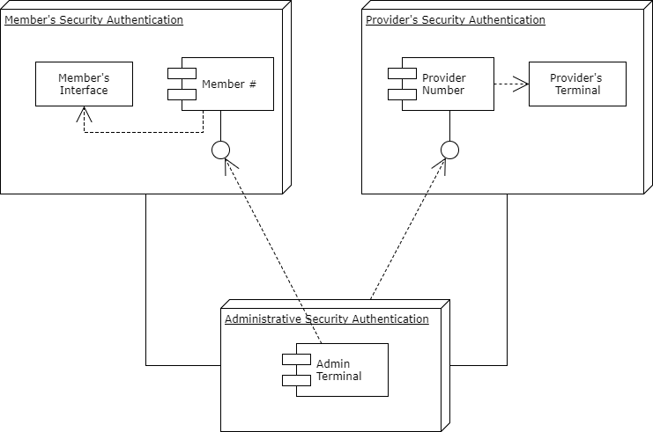

## **4.2 ChocAn’s Software Usability**

Though the development of our software for ChocAn will be complex, the internal complexity of the program should not reflect on the external use. It is important to keep note of the fact that the ChocAn services will be used by ChocAn employees and providers, not all of whom will have extensive knowledge in programming. The final product that we deliver should be as user friendly as possible, being fully functional in all areas while minimizing user failure to correctly use it. The usability should be optimized in a manner that will equally and equivocally use all the embedded functions to the best of ability.

Since usability is a paramount nonfunctional requirement, the program:

* Shall be user friendly to all users. As stated above, the program interface should interact in a friendly manner to all users. Avoiding error messages with terms and definitions only understandable by programmers is essential to creating a flowing service.
* Searching the text-files for member number and provider number shall be fast. If the file with provider number and user number grows, it should keep its efficiency in speed in searching and quickly retrieving the information about whether the entered information is valid

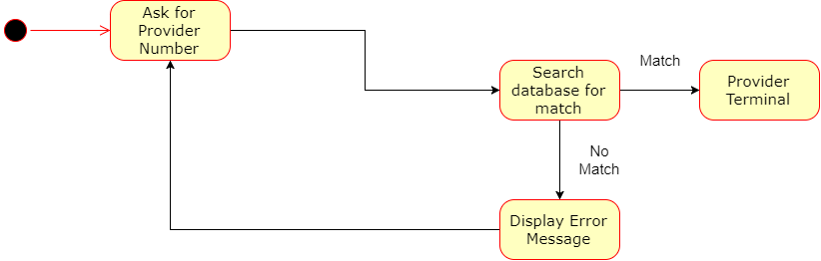

This diagram above represents the simplicity of the interface which will be in direct interaction with providers. The simple usability checks our nonfunctional requirement in making the ChocAn software easy to use, avoiding complex and lengthy error messages which none of the users would understand. Furthermore, we can give the user a limit on how many times they can enter their number to access the provider terminal. Once this limit number is reached or exceeded, the provider should not be able to enter another number for some time. However, this would be more towards the security side.

## **4.3 Verification Constraints**

An important nonfunctional requirement for our ChocAn project is to be able to let the member and providers know about the services which have taken place for them. For members, it would be important for them to know which services they have used, and have proof of the time/date the service took place. For providers, it will be important to keep track of their services so they know exactly how much to bill ChocAn at the end of the week. These different priorities for both the members and providers can be resolved by sending them a summary report of services:

* Members who have consulted ChocAn during the week shall receive an email attachment which summarizes information about the services they received at ChocAn.
* Providers who have provided service to members will receive an email attachment which summarizes the service they provided, member service was provided to, and the fee for that service. Therefore, the total fee on provider form can be verified by the summing the fees on the verification form.

### 4.3.1 Time Constraints

Since verification of the member and provider form is crucial, we as developers shall make sure that the forms are sent out in a consistent timely manner. Therefore:

* Both of the email attachments, to the members of ChocAn and the providers shall be sent out by midnight on Friday.

This way, both the systems at ChocAn and the member/provider will have proof of their services on forms sent out. In an unfortunate accident involving confusion about the paychecks, we can check at the verified forms to make sure that the fees and other information matches up.

# **5 Milestones and Deliverables**

Milestones are the required deliverables within this project. Each milestone has a specific timeline assigned to it. Hence, it can be considered as the contract between the product’s client (ChocAn) and the product’s developers (software developers). In this product, we have several milestones regarded as technical and literal documentations for various purposes serving both the product client and the software developers. These milestones are divided into two main sections as follow.

**5.1 Product Documentations**

This section includes three pre-coding documentations. These documentations layout the specification for the product requirements, design and test plan to ensure the delivery of a well-designed product that meets the client needs.

5.1.1 Requirement Documentation

This document is the Requirements Document. It consists of the standard set of requirements that must be contained in the project to deliver a satisfiable final product. The document also contains the product description, function, and nonfunctional requirements to lay out a path for the developers. The document is

5.1.2 Design Documentation

The design document will be responsible for giving the developing team an overall picture of the architecture of the software project. The design incorporates small and big details to create different paths leading up to the completion of different features. Additionally, it will allow the developers to more easily articulate which steps to take and help them envision obstacles that can be encountered.

5.1.3 Test Plan Documentation

The test plan will set the the test cases against which the software can be tested to make sure it is fully functional. The plan will play a crucial role in helping our team reach the final step before delivering the end product.

## **5.2 Software Documentation**

On the other hand, the second section focuses mainly on writing the software itself using prior documentation as reference. This step marks the final step in the chocAn project and, hence, the last deliverable that will be submitted to the client.